Letters Review J-K-L&How Are You课时6
复习素材：  - How Are You? Part 2 Animation  - How Are You? | 新授素材：  - Practice Page: These are my hands.  - Practice Page: These are my knees  - Practice Page: These are my legs  - Practice Page: These are my arms  - How Are You? Part 3 Animation
素材截图：
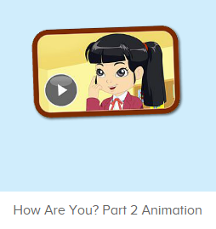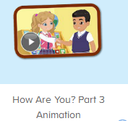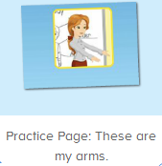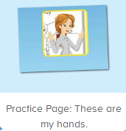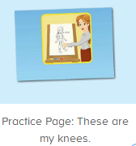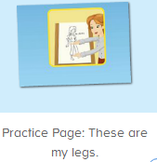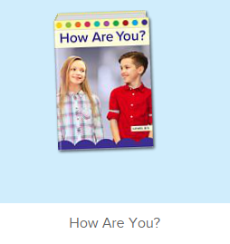
教学目标：
- 能从口语动画小剧场中听出关键句型和单词。
- 熟练掌握句型This is my.... These are my..., 并能接受自己的五官和身体部位。
- 掌握问候句式 “Hello. How are you?” “I am fine. How are you?” “I am fine. Thank you.”
教具准备：
1. 五官、身体各部位的词汇图卡
使用游戏：
1. Choosing Game 2. Whisper Game
教学步骤： |  | 备注
- 成果公布及展示：  T: Hello kids, good morning.  S: Good morning.  T: First, let's praise Lily, Andy, Peter, Jimmy... They have finished all their activities.  Everybody look,what is this? This is... (带领全体幼生回顾前三个字母已学过的关于我的名称)  S: This is my room/ my aquarium/ my hamster.  T: Is it right? Let’s listen and repeat.  S: Go to my room./ go to my aquarium/ go to my hamster.  Coco come here, please show us your room.  C: Yes.  C: This is my room.This is my bed. My bed is yellow.  T: Wow, terrific! Than  k you Coco.  Everybody together.  S: This is my room.This is my bed. My bed is yellow. （带领幼生整体描述一遍）  T: Well done! |  | 公布家庭活动成果并展示关于我（我的房间/我的鱼缸/我的仓鼠）
- 集体学习活动：  口语动画小剧场 1  T: Now, matching game. Boys and Girls, are you ready?（教师打开图1口语动画素材，请幼生分组抢答）  S: This is my ...  T: Wonderful.Boys first,girls come on!Let’s continue.  Bs:This is my ...  Gs:This is my ...  T: This time, fast reaction,when you hear This is my face, this is my eye,... Please say and do the action, OK? （教师再次播放口语动画，在播放到This is ...等关键句子后暂停，示意让幼生跟读和做动作）  T: follow it.  S: What is this?  This is my face. （在幼生跟读的同时，教师也做TPR提示）  This is my eye./ Eyes.  This is my mouth.  This is my ear.  This is my nose.  T: Excellent.Again.  S: ...  T:Roy and Lynn,come and show.  R: What is this ?（挑选两位幼生互相对话，请他们指着对方的身体部位）  L: This is my mouth.  R: What is this?  L: This is my ear.  T: Good job, thank you, Roy, go back to your seat please. Who wants to try? （继续邀请1-2组幼生，复习句子）  S: Let me try.  口语动画小剧场 2  T: Now, let’s watch the video, listen and repeat. （教师打开图2口语动画素材，在关键句子后暂停，让幼生跟读。）  S:Let’s practice. This is my eye.  T:Good,Kelly,listen and repeat.（请单个幼生跟读，再集体跟读）  K:These are my eyes.  T: Fantastic,together.  S:These are my eyes.  T:The next,Peter（继续上面的操作）  P:This is my body.  L:This is my head.  R:This is my arm. These are my arms.  K:This is my hand.  C:This is my hand.  K&C:These are hands.  N:These are my fingers. This is my finger.  L:This is my leg. These are my legs.  K:This is my knee.  N:This is my foot.  L:This is my toe.  ...  T: Good! Now, let’s listen and point. （教师重复播放图2口语动画素材，让幼生仔细听,跟着做）  S: ...  T: Wonderful.This time, listen and repeat. （依次播放图3-6让幼生跟读关键句型）  S: These are my arms/knees/hands/legs.  T:Awesome.Magic name.Carrie/Marion...（教师点击平台，同时点名幼生，被叫到名字的幼生站起来说并做动作）  C/M:...  T: What is this? /What are these?（询问全体幼生）  S: This is /These are....（全体和单个幼生均有回答）  T: Well done,“I say you do”. （分组活动，A组说B组做，互相交换）  S1: This is my ...  S2:...  T: Black, come here. You will be the little teacher. Please choose a card and ask your students.（教师拿出五官和身体部位的词汇图卡让幼生抽，幼生示意抽中的部位提问其余幼生）  Black: What is this?/What are these?  S: This is.../These are ...  Black: What are these?  S:These are ...  T: Good job! Black, go back to your seat please.  Let’s do it one by one. （让所有幼生抽取词汇图卡，不让老师看到，向老师提问，老师作答）  T: Please choose the card.  S1: What is this? （假若幼生抽到的是鼻子，幼生指着鼻子提问）  T: This is my nose.（教师也指着自己对应的部位）  T: Is it right? （教师把幼生抽中的词汇图卡给其余幼生看，求证其余幼生）  S: Yes.  T: Good job! Continue! Please choose the card.  S2: What are these?  T: These are my eyes.  T: Is it right?  S: Yes.!  趣味图书  T: Book time! （教师打开图7图书素材）  T: What’s the name of this book?  S: How Are You?  T: Let’s check it, listen again.  Is it right?  S: Yes!  T: Listen and repeat. （播放一次书名，让幼生跟读）  S: How Are You?  T: Tell me again. What’s the name of this book?  S: How Are You?  T: Now, let’s perform the book. （教师打开图7故事图书，播放至学过的部分，请幼生边跟读边做TPR）  S: Hello! How are you?  I am fine. How are you?  I am fine. What is your name?  My name is Kate. What is your name?  My name is Reed. It is nice to meet.  T: Good! Now, let’s listen and repeat. Are you ready? （每次播放1句就暂停，让幼生跟读，以此类推到第12页）  S: Hello! How are you?  I am fine. How are you?  I am fine. What is your name?  My name is Kate. What is you name?  My name is Reed. It is nice to meet you.  Hello, Mike. How are you?  T: Repeat again. （重复播放第12页）  S: Hello, Mike. How are you? （让幼生跟读3-5遍）  T: Who is this?  S: Mike.  T: Really? Let’s check it. （再播放一遍）  Is it right?  S: Yes!  T: Let’s say Hello to Mike.  T: Hello, Mike. How are you?  S: Hello, Mike. How are you?  T: One more time.  S: Hello, Mike. How are you?  T: Continue! Listen and repeat. （播放第14页）  S: I am fine. How are you?  T: One more time.  S: I am fine. How are you?  T: Hello, Kids. How are you?  I am ... （教师做提示）  S: I am fine. How are you?  T: Good! Let’s do it one by one.  T: Hello, Lily. How are you?  Lily: I am fine. How are you?  T: Hello, .... How are you?  S1: I am fine. How are you?  T: Hello, ... . How are you?  S2: I am fine. How are you?（与逐个幼生练习对话）  T: Good job! Who wants to be the little teacher?  S: Let me try.  T: Lisa, come here, you will be the little teacher. Say Hello to your students.  L: Hello, ... . How are you?  S3: I am fine. How are you? （邀请多位幼生做小老师）  T: Good! Now, let’s listen and repeat again. （请幼生再跟读一遍）  S: Hello! How are you?  I am fine. How are you?  I am fine. What is your name?  My name is Kate. What is your name?  My name is Reed. It is nice to meet.  Hello, Mike. How are you?  I am fine. How are you?  I am fine. Thank you.  T: Good job!  T:Very good! Now let's count our tickets.  Who can try?  S:Let me try.  T:Tommy please.  Where can we find our tickets?  S: "About me".  T:Tommy click it please.  Now let's count with ABCmouse.  S&ABCmouse: One,two,three......  T: So we have ten tickets today, great job! Thank you Tommy. |  | 图1：  图2：  图3：  图4：  图5：  图6：  图7：
三、家庭游戏活动布置：  T: Now, I’ll show you the activities. (将已放入功课的作业界面打开)  Here are your activities for today.  You have to do these activities.  How many activities? Let’s count together.  S: One, two, three, four.  T: You have to do these activities, OK?  S: OK!  T: Each of them, you need to play 5 times. OK?  S: OK!  T: Look at me, I will show you.  Please listen and repeat. (加上肢体动作演示)  OK?  S: OK!  T: Clear?  S: Yes!  T: Who can show us how to do it?  S: Let me try!  T: Mary, come here and show us how to do the activities. (每一位幼生上前演示如何操作)  T: Good job! Thank you Mary!  T: Who can retell how to do it?  S: Let me try!（教师可引导幼生）  T: Good! Please finish your activities and show me tomorrow, OK?  S: OK  T: Class is over, Goodbye, everyone.  S: Goodbye. |  | 家庭游戏活动：  