Letters Review J-K-L&How Are You课时7
复习素材：  - How Are You? Animation  - How Are You? | 新授素材：  - How Are You? Practice  - How Are You? Memory match
素材截图：
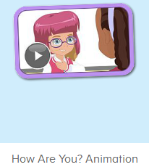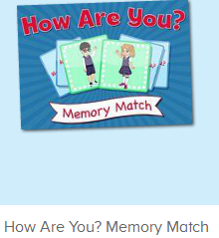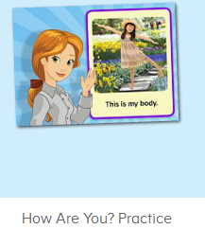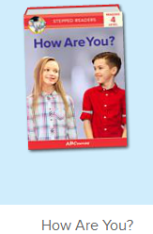
教学目标：
- 能从口语动画小剧场中听出关键句型和单词。
- 熟练掌握故事图书的句子，能跟随图书播放的节奏说出句子。
- 熟练掌握基本问候句式。
教具准备：
1. 五官、身体各部位的词汇图卡 2. 装扮道具
使用游戏：
1. Choosing Game 2. Role Play
教学步骤： |  | 备注
- 成果公布及展示：  T: Hello kids, good morning.  S: Good morning.  T: First, let's praise Lily, Andy, Peter, Jimmy... They have finished all their activities.  Everybody look,what is this? This is... (带领全体幼生回顾前三个字母已学过的关于我的名称)  S: This is my room/ my aquarium/ my hamster.  T: Is it right? Let’s listen and repeat.  S: Go to my room./ go to my aquarium/ go to my hamster.  Coco come here, please show us your room.  C: Yes.  C: This is my room.This is my bed. My bed is yellow.  T: Wow, terrific! Than  k you Coco.  Everybody together.  S: This is my room.This is my bed. My bed is yellow. （带领幼生整体描述一遍）  T: Well done! |  | 公布家庭活动成果并展示关于我（我的房间/我的鱼缸/我的仓鼠）
- 集体学习活动：  口语动画小剧场  T: Now, let’s watch the video, listen and repeat. （教师打开图1口语动画素材，在关键句子后暂停，让幼生跟读，进行复习）  S: Hello. How are you? ...  ...  T: Hello! How are you?  S: I am fine. How are you?  T: I am fine. Thank you.  My name is Abby. What is your name?  S: My name is ... . It is nice to meet you.  T: Good job! Let’s play the Choosing Game. Please choose a card and ask me. Let’s do it one by one. （教师拿出五官和身体部位的词汇图卡让幼生抽，A组幼生示意抽中的部位提问B组幼生）  S1: What is this?  S2: This is my ...  T: Is it right?  S: Yes!  S2: What are these?  S1: These are my ...  T: Is it right?  S: Yes!  T: Good job! Who wants to be the little teacher?  S: Let me try!  T: Mandy, come here please. You will be the little teacher. （让其余幼生逐一抽词汇卡片，询问不同的幼生）  G: What is this?  M: This is ...  K: What are these?  L: These are ...  T: Good job! Now let’s watch the video, listen and repeat together!  T: Ready! Go! （让幼生最后跟读动画中的关键句子）  S: Hello! How are you? ...  T: Now, let’s do some role play. Tom, come here please. （教师带上装扮道具，和幼生练习对话）  T: Hello! How are you? （做出握手的动作）  Tom: I am fine. How are you?  T: I am fine. Thank you!  T: Excellent! Thank you, Tom. Who wants to try?  S: Let me try!  T: Ron and Jenny come here please.（请2位幼生上台，让幼生互相为对方挑选装扮道具，进行对话练习）  R: Hello! How are you?  J: I am fine. How are you?  R: I am fine. Thank you!  T: Nice! Who can try? （继续邀请幼生继续操练）  S: Let me try!...  小小配音员  T: Now, let’s record our voice. （点击图2录音素材）  Let’s listen teacher’s voice. （点击画面上的教师）  What can you hear?  S: This is my face.  T: Let’s check. Is it right? （再次点击画面上的教师）  S: Yes.  T: Follow it.  S: This is my face.  T: What is this?  S: This is my face.  T: Now, let’s record our voice. What is this? Ready! Go! （点击录音）  S: This is my face.  T: Let’s listen.（播放录制的声音）What is this?  S: This is my face.  T: Good job! Who wants to try?  S: Let me try.  T: Lily, come here please.（让幼生自己操作录音）  T: Ready! Go! （先点击画面上的教师，再示意幼生录音）  Lily: This is my face.  T: Let’s listen Lily’s voice. （播放刚刚录制的声音）  T: Is it the same?  S: Yes.  T: Excellent!  T: Now, the next one. Let’s listen teacher’s voice. （点击画面上的教师）  What can you hear?  S: Theses are my eyes.  T: Let’s check it. Is it right? （再次点击画面上的教师）  S: Yes.  T: Follow it.  S: These are my eyes.  T: What are these?  S: These are my eyes.  T: Now, let’s record our voice. What are these? Ready! Go! （点击录音）  S: These are my eyes.  T: Let’s listen.（播放录制的录音）What are these?  S: These are my eyes.  T: Good job! Who wants to try?  S: Let me try.  T: Leon, come here please.  T: Ready! Go! （先点击画面上的教师，再示意幼生录音）  Leon: These are my eyes.  T: Let’s listen Leon’s voice.（播放刚刚录制的声音）  T: Is it the same?  S: Yes.  T: Well done! Continue.  S: ...  记忆对对碰  T: Good! Now let’s play a memory match game. Who can try? （教师点击图3进入memory match game，一共可玩三轮，教师可邀请几位幼生上前操作，其他幼生跟读发音）  S: Let me try.  T: Please say the name of this game.  S: How Are You Memory Match.  T: Lisa, have a try. Everybody listen. （点击翻开一张图片）  T: Look and listen carefully.  T: What can you hear? （指着翻过来的图片）  S: I am fine.  T: Nice, another one.  What can you hear?  S: My name is Sarah.  T: And this one. Wow, bingo! （继续翻开下一张，如果翻到同样的，就两张同时消失）  T: The next one. Who can try? （轮流请幼生上来进行游戏操作）  S: Let me try...  T: Follow it, Please. （时间允许的情况下，请幼生跟读句子）  S: ...  小小配音员  T: Now, let’s read the book - How Are You. （教师点击播放图4故事图书，请幼生跟读）  S: Hello! How are you?  I am fine. How are you?  I am fine. What is your name?  My name is Kate. What is your name?  My name is Reed. It is nice to meet you.  Hello, Mike. How are you?  I am fine. How are you?  I am fine. Thank you!  T: Good! Now, I will turn off the sound, let’s be the little recorder.  Are you ready?  S: Yes, we are ready.  S: Hello! My name is ...  T: Good job!  T:Very good! Now let's count our tickets.  Who can try?  S:Let me try.  T:Tommy please.  Where can we find our tickets?  S: "About me".  T:Tommy click it please.  Now let's count with ABCmouse.  S&ABCmouse: One,two,three......  T: So we have ten tickets today, great job! Thank you Tommy. |  | 图1：  图2：  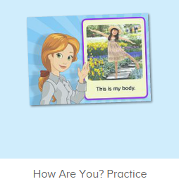  图3：  图4：  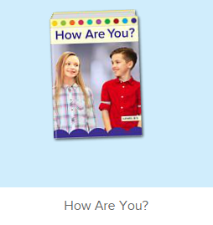
三、家庭游戏活动布置：  T: Now, I’ll show you the activities. (将已放入功课的作业界面打开)  Here are your activities for today.  You have to do these activities.  How many activities? Let’s count together.  S: One, two, three, four.  T: You have to do these activities, OK?  S: OK!  T: Each of them, you need to play 5 times. OK?  S: OK!  T: Look at me, I will show you.  Please listen and repeat. (加上肢体动作演示)  OK?  S: OK!  T: Clear?  S: Yes!  T: Who can show us how to do it?  S: Let me try!  T: Mary come here and show us how to do the activities. (每一位幼生上前演示如何操作)  T: Good job! Thank you Mary!  T: Who can retell how to do it?  S: Let me try!（教师可引导幼生）  T: Good! Please finish your activities and show me tomorrow, OK?  S: OK  T: Class is over, Goodbye, everyone.  S: Goodbye. |  | 家庭游戏活动：

