Letters Review J-K-L&How Are You课时8
学习素材：
- How Are You? Animation
- How Are You? Quiz
- How Are You?
- How Are You? Memory Match
- My Body Music Video
素材截图：
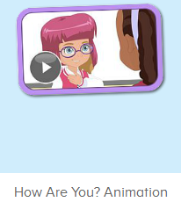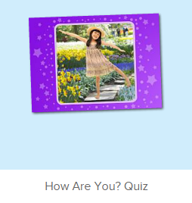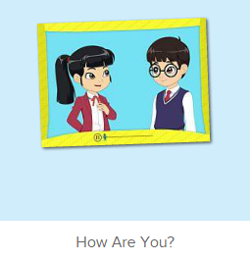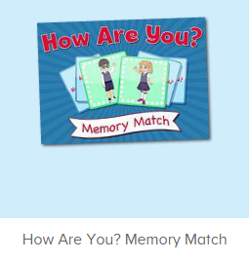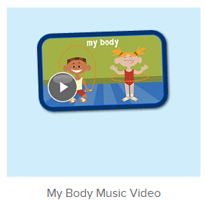
教学目标：
- 能熟练掌握五官和身体各部位词汇。
- 能用This is...和These are的句型介绍自己的五官和身体各部位。
- 熟练掌握基本问候句型。
教具准备：
1. 五官、身体各部位的词汇图卡 2. 装扮道具 3. 教师自画像
使用游戏：
1. Role play 2. 小小绘画家
教学步骤： | 备注
- 成果公布及展示：  T: Hello kids, good morning.  S: Good morning.  T: First, let's praise Lily, Andy, Peter, Jimmy... They have finished all their activities.  Everybody look,what is this? This is... (带领全体幼生回顾前三个字母已学过的关于我的名称)  S: This is my room/ my aquarium/ my hamster.  T: Is it right? Let’s listen and repeat.  S: Go to my room./ go to my aquarium/ go to my hamster.  Coco come here, please show us your room.  C: Yes.  C: This is my room.This is my bed. My bed is yellow.  T: Wow, terrific! Than  k you Coco.  Everybody together.  S: This is my room.This is my bed. My bed is yellow. （带领幼生整体描述一遍）  T: Well done! | 公布家庭活动成果并展示关于我（我的房间/我的鱼缸/我的仓鼠）
- 集体学习活动：  口语动画小剧场  T: Now, let’s watch the video, listen and repeat. （教师打开图1口语动画素材，在关键句子后暂停，让幼生跟读，进行复习）  S: Hello. How are you? ...  ...  T: Hello! How are you?  S: I am fine. How are you?  T: I am fine. Thank you.  My name is Abby. What is your name?  S: My name is ... . It is nice to meet you.  T: Good job! Let’s play the Choosing Game. Please choose a card and ask me. Let’s do it one by one. （教师拿出五官和身体部位的词汇图卡让幼生抽，A组幼生示意抽中的部位提问B组幼生）  S1: What is this?  S2: This is my ...  T: Is it right?  S: Yes!  S2: What are these?  S1: These are my ...  T: Is it right?  S: Yes!  T: Good job! Who wants to be the little teacher?  S: Let me try!  T: Mandy, come here please. You will be the little teacher. （让其余幼生逐一抽词汇卡片，询问不同的幼生）  G: What is this?  M: This is ...  K: What are these?  L: These are ...  T: Now, let’s do the quiz. Listen carefully and tell me what can you hear.  （打开图2素材，让幼生聆听老师的问句）  T: What can you hear?  S: This is my face.  T: Good! One more time.  S: This is my face.  T: Who can try?  S: Let me try.  T: Leo, come here, please choose “This is my face.”  T: Good job! Thank you, Leo.  T: Next one, Candy, come here.  Listen and retell.  S: These are my eyes.  T: Candy, please choose “These are my eyes.”  T: Well done! Continue... （以此类推）  趣味复读机  T: Let’s watch the video. And then tell me what can you hear.  （教师播放图3素材，让幼生带任务聆听）  T: Who can try?  I can hear ...  S: I can hear How are you.../ My name is ... （幼生把听到的说出来）  T: Good job! Now, let’s listen and repeat. （每播放一句暂停，让幼生跟读）  S: What is your name?  My name is Ken. What is your name?  My name is Lina. ...  T: Good job! Let’s have a match. Boys and girls. Are you ready? （分性别跟读句子）  Girls: What is your name?  Boys: My name is ... （可多种形式跟读）  T: Good job! Girls Win!  T: What is your name? （按顺序询问幼生，然后让幼生询问他旁边的幼生，以此类推，检验每个幼生的掌握情况）  S1: My name is Peter. What is your name?  T: My name is Abby.  S1: What is your name?  S2: My name is Lily. What is your name?  S1: My name is Peter.  S2: What is your name?  S3: My name is Kate. What is your name?  S2: My name is Lily.  T: Hello! How are you? （同上，检验每个幼生的掌握情况）  S1: I am fine. How are you? （幼生若有卡壳，教师可做提示）  T: I am fine. Thank you!  S1: Hello! How are you?  S2: I am fine. How are you?  S1: I am fine. Thank you.  T: You all did a good job! Now, let’s do some role play. （老师拿出装扮道具，邀请幼生进行对话练习）  T: Charles and Jennie come here please.（每次请2位幼生上台，让幼生互相为对方挑选装扮道具，进行对话练习）  C: What is your name?  J: My name is Jennie. What is you name?  C: My name is Charles.  T: Continue. Say “Hello...”  C: Hello! How are you?  J: I am fine. How are you?  C: I am fine. Thank you!  T: Well done! Thank you, Charles and Jennie, go back to your seat please. Who want to try?  S: Let me try...  记忆对对碰  T: Good! Now let’s play a memory match game. Who can try? （教师点击图4进入memory match game，一共可玩三轮，教师可邀请几位幼生上前操作，其他幼生跟读发音）  S: Let me try.  T: Please say the name of this game.  S: How Are You Memory Match.  T: Lisa, have a try. Everybody listen. （点击翻开一张图片）  T: Look and listen carefully.  T: What can you hear? （指着翻过来的图片）  S: I am fine.  T: Nice, another one.  What can you hear?  S: My name is Sarah.  T: And this one. Wow, bingo! （继续翻开下一张，如果翻到同样的，就两张同时消失）  T: The next one. Who can try? （轮流请幼生上来进行游戏操作）  S: Let me try...  T: Follow it, Please. （时间允许的情况下，请幼生跟读句子）  S: ...  快乐唱片机  T: Now, let’s sing the song - My Body together. （打开图5歌曲素材，请幼生一起唱）  S: My head is on top of my body. ...  T: Good! Now, everybody stand up, let’s sing and dance. （教师再次播放歌曲，请幼生边唱边做TPR）  S: My head has...  T: Good! Now, let’s play a game. We sing and dance one bye one. （舞蹈接龙游戏：请一组幼生上台排成一行，播放音乐，每位幼生跟随音乐按顺序表演一句歌词）  T: Team1 come here. （可分几组进行比赛）  Are you ready?  Team1: Yes.  T: Ready! Go!  Team1: ...  T: Wow, good job! Now, Team2 come here please.  Team2: ...  T: Well done! Team 1 win!  T:Very good! Now let's count our tickets.  Who can try?  S:Let me try.  T:Tommy please.  Where can we find our tickets?  S:"About me".  T:Tommy click it please.  Now let's count with ABCmouse.  S&ABCmouse:One,two,three ....  T:So we have ten tickets today,great job! Thank you Tommy. | 图1：  图2：  图3：  图4：  图5：
三、家庭游戏活动布置：  T: Now, I’ll show you the activities. (将已放入功课的作业界面打开)  Here are your activities for today.  You have to do these activities.  How many activities? Let’s count together.  S: One, two, three, four.  T: You have to do these activities, OK?  S: OK!  T: Each of them, you need to play 5 times. OK?  S: OK!  T: Look at me, I will show you.  Please listen and repeat. (加上肢体动作演示)  OK?  S: OK!  T: Clear?  S: Yes!  T: Who can show us how to do it?  S: Let me try!  T: Mary come here and show us how to do the activities. (每一位幼生上前演示如何操作)  T: Good job! Thank you Mary!  T: Who can retell how to do it?  S: Let me try!（教师可引导幼生）  T: Good! Please finish your activities and show me tomorrow, OK?  S: OK  T: Class is over, Goodbye, everyone.  S: Goodbye. | 家庭游戏活动：

