Letters Review J-K-L&How Are You课时9
学习素材：
- How Are You? Part 3 Animation
- How Are You? Practice
- How Are You? Memory match
- How Are You? Quiz
- How Are You?
- My Body Music Video
素材截图：
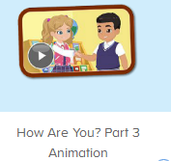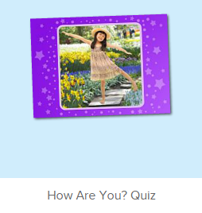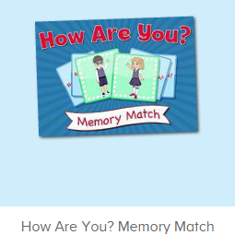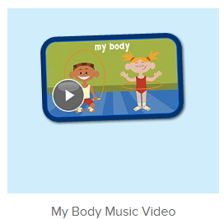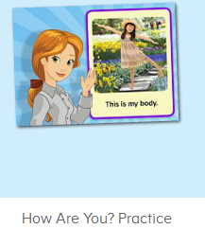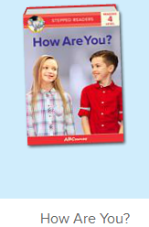
教学目标：
- 能熟练掌握五官和身体各部位词汇。
- 能用This is...和These are... 的句型介绍自己的五官和身体各部位。
教具准备：
1. 教师自画像
使用游戏：
1. 小小绘画家
教学步骤： | 备注
- 成果公布及展示：  T: Hello kids, good morning.  S: Good morning.  T: First, let's praise Lily, Andy, Peter, Jimmy... They have finished all their activities.  Everybody look,what is this? This is... (带领全体幼生回顾前三个字母已学过的关于我的名称)  S: This is my room/ my aquarium/ my hamster.  T: Is it right? Let’s listen and repeat.  S: Go to my room./ go to my aquarium/ go to my hamster.  Coco come here, please show us your room.  C: Yes.  C: This is my room.This is my bed. My bed is yellow.  T: Wow, terrific! Thank you Coco.  Everybody together.  S: This is my room.This is my bed. My bed is yellow. （带领幼生整体描述一遍）  T: Well done! | 公布家庭活动成果并展示关于我（我的房间/我的鱼缸/我的仓鼠）
- 集体学习活动：  趣味图书  T: Book time! （教师打开图1图书素材）  T: What’s the name of this book?  S: How Are You?  T: Good, let’s perform the book. （请幼生站起来边跟读边做TPR）  S: Hello! How are you?  I am fine. How are you?  I am fine. What is your name?  My name is Kate. What is your name?  My name is Reed. It is nice to meet.  T: Good! Now, role play. Lucy,Benjamin try it.（请幼生扮演角色问好对话,1-2组即可）  L: Hello! How are you?  B:I am fine. How are you?  L:I am fine. What is your name?  B:My name is Benjamin. What is your name?  L:My name is Lucy. It is nice to meet.  T: Good job!  记忆对对碰  T: Good! Now， memory match.（教师点击图2，可邀请几位幼生上前操作，其他幼生跟读发音）  S: Let me try.  T: Lisa, have a try. Everybody listen. （点击翻开一张图片）  T: Look and listen carefully.  T: What can you hear? （指着翻过来的图片）  S: I am fine.  T: Nice, another one.  What can you hear?  S: My name is Sarah.  T: And this one. Wow, bingo! （继续翻开下一张，如果翻到同样的，就两张同时消失）  T: The next one. Who can try? （轮流请幼生上来进行游戏操作）  S: Let me try...  T: Follow it, Please. （时间允许的情况下，请幼生跟读句子）  小小配音员  T: Now,fast reaction. （点击图3）  What do you hear?  S: This is my face.  T: Peter （请单个幼生回答,依次完成剩余内容）  P: This is my face.  T: Wow,give me five.Go ahead.  S:...  T: Excellent!  T: Now, the next one.  S1: Theses are my eyes.  T: Let’s check it. Is it right? （再次点击画面上的教师）  S: Yes.  T: Follow it.  S: These are my eyes.  T: What are these?  S: These are my eyes.  T: Well done! Continue.  S: ...  T: Now, let’s do the quiz. Listen and choose.  （打开图4素材，让幼生聆听老师的问句）  S: This is my face.  T: Good! Mary,come and click it.  M: This is my face.  T: Bingo, the next.Who can try?  S: Let me try.  T: Leo, come on.  L:These are my eyes..  T: Good.Next one, Candy, come here.  C: These are my....  T: Well done! Continue... （以此类推）  口语动画小剧场  T: Now, let’s watch the video, listen and repeat. （教师打开图5口语动画素材，在关键句子后暂停，让幼生跟读。）  S:Let’s practice. This is my eye.  T:Good,Kelly,listen and repeat.（请单个幼生跟读，再集体跟读）  K:These are my eyes.  T: Fantastic,together.  S:These are my eyes.  T:The next,Peter（继续上面的操作）  P:This is my body.  L:This is my head.  R:This is my arm. These are my arms.  K:This is my hand.  C:This is my hand.  K&C:These are hands.  N:These are my fingers. This is my finger.  L:This is my leg. These are my legs.  K:This is my knee.  N:This is my foot.  L:This is my toe.  ...  T: Good! Now, let’s listen and point. （教师重复播放图5口语动画素材，让幼生仔细听,跟着做）  S: ...  快乐唱片机  T: Now, let’s sing the song - My body together. （打开图6歌曲素材，请幼生一起唱）  S: My head is on top of my body. ...  T: Good! Now, everybody stand up, let’s sing and dance. （教师再次播放歌曲，请幼生边唱边做TPR）  - ..  T:Very good! Now let's count our tickets.  Who can try?  S:Let me try.  T:Tommy please.  Where can we find our tickets?  S:"About me".  T:Tommy click it please.  Now let's count with ABCmouse.  S&ABCmouse:One,two,three ....  T:So we have ten tickets today,great job! Thank you Tommy. | 图1：  图2：  图3：  图4：  图5：  图6：
三、家庭游戏活动布置：  T: Now, I’ll show you the activities. (将已放入功课的作业界面打开)  Here are your activities for today.  You have to do these activities.  How many activities? Let’s count together.  S: One, two, three, four.  T: You have to do these activities, OK?  S: OK!  T: Each of them, you need to play 5 times. OK?  S: OK!  T: Look at me, I will show you.  Please listen and repeat. (加上肢体动作演示)  OK?  S: OK!  T: Clear?  S: Yes!  T: Who can show us how to do it?  S: Let me try!  T: Mary come here and show us how to do the activities. (每一位幼生上前演示如何操作)  T: Good job! Thank you Mary!  T: Who can retell how to do it?  S: Let me try!（教师可引导幼生）  T: Good! Please finish your activities and show me tomorrow, OK?  S: OK  T: Class is over, Goodbye, everyone.  S: Goodbye. | 家庭游戏活动：

