My Body - 课时1
素材内容：
1. My Body, Part 1-A Animation
2. My Body, Part 1 Animation
3. My Body Music Video
4. Practice Page: This is my body.
5. Practice Page: This is my head.
素材截图：
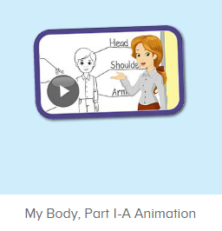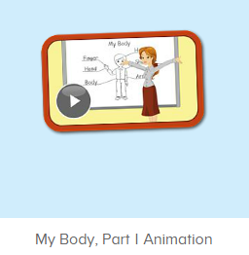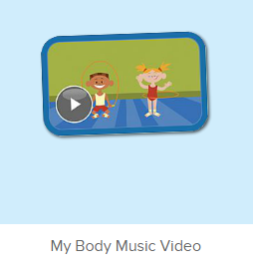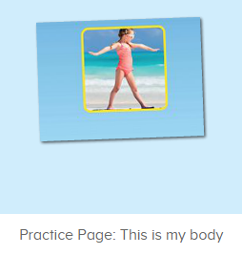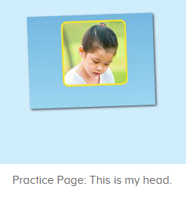
年龄段：小班下
教学目标：
- 能理解并认读词汇head, body, 发音与平台一致。
- 能活用句型，This is my ...
教具准备：1. This is my body/ head图卡
使用游戏：
1. I do you say 2. choosing card
教学步骤：
一、成果公布及展示：  T: Hello Kids, good morning.  S: Good morning.  T: First, let’s praise Lily, Andy, Peter, Jimmy... They have finished all their activities.  Everybody look, what is this? This is ...  S: This is about me.  T: Is it right? Let’s listen and repeat.  S: About me.  T: Good! So what is this?  This is ...  S: This is about me.  T: Good! What is this?  S: This is my pet park/ my room/ avatar ...  T: Is it right? Let’s listen and repeat.  S: Go to pet park./ Go to my room./ Go to my hamster./ Change my avatar.  T: Good! Which one do you like?  I like ... （教师做提示）  S: I like my room./ my pet part...  T: Good job! Lily, which one do you like?  I like ...  Lily: I like my room. （可再提问多个幼生）  T: Good job! Can you introduce about me?  Lily: Yes.  T: This is ... （教师做提示）  Lily: This is about me. This is my room. I like my room.  T: Good job! Now, you are all Lily, let’s say it again.  S: This is about me. This is my room. I like my room.  T: Good job! Thank you Lily.  - 集体学习活动：  口语动画小剧场  T: Now, let’s watch the video, listen and no voice. （打开图1口语动画素材，请幼生认真观看和听，不跟读）  What can you hear?  S: This is ...  T: Right? Let’s check it, listen again. （教师再次播放口语动画，在幼生说出来的地方进行鼓励，在幼生没有说出来的地方进行提示）  T: This time, when you hear body, please clap your hands, OK?  S: OK.  T: Good! This time, when you hear head, please stand up, OK?  S: OK.  T: Good! Now, let’s watch again. When you hear This is my body and This is my head, please follow it, OK? （教师再次播放口语动画，在播放到This is my body和This is my head的句子后暂停，示意让幼生跟读）  T: Follow it.  S: This is my body. / This is my head. （在幼生跟读的同时，教师也做TPR进行提示）  T: One more time.  S: This is my body./ This is my head.  T: Good job! What is this? （教师指着头，询问幼生）  This is my ...  S: This is my head.  T: Good job! What is this? （教师示意全身，询问幼生）  This is my ...  S: This is my body.  T: Good job! Now stand up, let’s do the action together. （带领幼生边说句子边做TPR）  S: This is my head./ This is my body. （带领幼生做2-3次）  T: Good job! Sit down please. Now, let’s play I say you do. （教师说出句子，幼生做TPR）  T: This is my head./ This is my body.  T: Good job! Let’s play I do you say. Who can be the little teacher?  S: Let me try.  T: Jennifer, come here, you do the action, and other people say the sentences, OK? （邀请幼生上台做动作，其余幼生说出句子）  S: OK!  S: This is my head./ This is my body.  T: Good job! Thank you, Jennifer. （可再邀请多位幼生上台做动作，其余幼生说出句子）  T: Now, let’s watch the video again. （教师播放图2口语动画素材-My Body Part 1 Animation, 在body和head的部分，示意幼生一起做TPR， 其余部分让幼生继续观看）  快乐唱片机  T: Now, let’s enjoy the music video, listen and no voice. （打开图3歌曲素材，请幼生认真观看和听，不跟唱）  What can you hear?  S: My body ...  T: Right? Let’s check, listen.  Wow! Good job!  T: This time, when you hear body and head, please stamp your feet, OK?  S: OK!  趣味复读机  T: Now, listen and repeat. （打开图4素材，请幼生跟读发音）  What can you hear?  S: This is my body.  T: Good! Follow it please.  S: This is my body. （让幼生跟读3-5遍）  T: Nice! Let’s add the action.  T: This is my body. （幼生边做边说，示意幼生一起）  S: This is my body.  T: Good job! What is this?  This is ... （教师做TPR提示）  S: This is my body. （提示幼生做TPR）  T: Good job! Lisa, What is this? （教师做TPR提示，可再询问多位幼生）  Lisa: This is my body. （提示幼生做TPR）  T: Good job!  T: What about this, listen and repeat. （打开图5素材，请幼生跟读发音）  S: This is my head.  T: Good! Follow it please.  S: This is my head. （让幼生跟读3-5遍）  T: Nice! Let’s add the action.  T: This is my head. （教师边做边说，示意幼生一起）  S: This is my head.  T: Good job! What is this?（教师做TPR提示）  S: This is my head. （提示幼生做TPR）  T: Good job! Linda, What is this?（教师做TPR提示，可再询问多位幼生）  Linda: This is my head.  T: Good job!  Choosing Card  T: Good job! Let’s play choosing card game. You choose the card one by one, and say the sentence, OK? （教师拿出head, body的图卡）  S: OK  S: This is my head./ This is my body.  T: Good job!  T:Very good! Now let's count our tickets.  Who can try?  S:Let me try.  T:Tommy please.  Where can we find our tickets?  S: "About me".  T:Tommy click it please.  Now let's count with ABCmouse.  S&ABCmouse: One,two,three......  T: So we have ten tickets today, great job! Thank you Tommy. | 公布家庭游戏活动成果并展示关于我版块  图1：  图2：  图3：  图4：  图5：
三、家庭游戏活动布置：  T: Now, I’ll show you the activities. (将已放入功课的作业界面打开)  Here are your activities for today.  You have to do these activities.  How many activities? Let’s count together.  S: One, two, three, four.  T: You have to do these activities, OK?  S: OK!  T: Each of them, you need to play 5 times. OK?  S: OK!  T: Look at me, I will show you.  Please listen and repeat. (加上肢体动作演示)  OK?  S: OK!  T: Clear?  S: Yes!  T: Who can show us how to do it?  S: Let me try!  T: Mary come here and show us how to do the activities. (每一位幼生上前演示如何操作)  T: Good job! Thank you Mary!  T: Who can retell how to do it?  S: Let me try!（教师可引导幼生）  T: Good! Please finish your activities and show me tomorrow, OK?  S: OK  T: Class is over, Goodbye, everyone.  S: Goodbye. | 家庭游戏活动：

