My Body - 课时3
复习素材：  - My Body, Part 1 Animation | 新授素材：  - My Book  - Hello! My name is Bella.  - How are you? I’m fine.  - This is my body.  - This is my head.  2. My Body, Part 1-B Animation  3. Practice Page: This is my shoulder  4. Practice Page: This is my arm  5. Practice Page: These are my arms
素材截图：
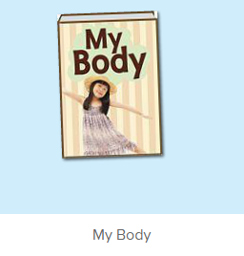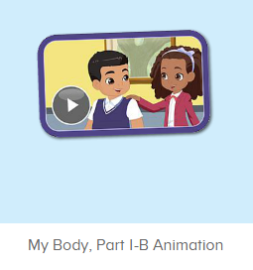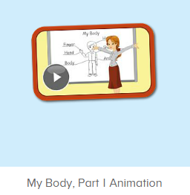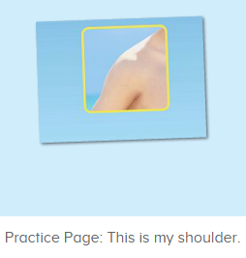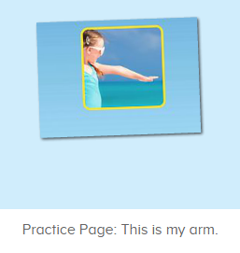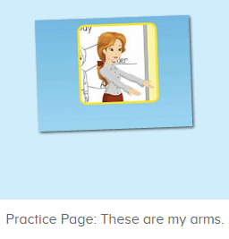
教学目标：
- 熟练掌握词汇shoulder, arm, 发音与平台一致。
- 熟练掌握句型，This is my ...和 These are my ...，并理解其区别。
- 学习故事图书前6句，掌握简单句型
教学用具：
1. Head, body图卡
使用游戏：
1.choosing card 2. I do you say
教学步骤：
- 成果公布及展示：  T: Hello Kids, good morning.  S: Good morning.  T: First, let’s praise Lily, Andy, Peter, Jimmy... They have finished all their activities.  Everybody look, what is this? This is ...  S: This is about me.  T: Is it right? Let’s listen and repeat.  S: About me.  T: Good! So what is this?  This is ...  S: This is about me.  T: Good! What is this?  S: This is my pet park/ my room/ avatar ...  T: Is it right? Let’s listen and repeat.  S: Go to pet park./ Go to my room./ Go to my hamster./ Change my avatar.  T: Good! Which one do you like?  I like ... （教师做提示）  S: I like my room./ my pet part...  T: Good job! Lily, which one do you like?  I like ...  Lily: I like my room. （可再提问多个幼生）  T: Good job! Can you introduce about me?  Lily: Yes.  T: This is ... （教师做提示）  Lily: This is about me. This is my room. I like my room.  T: Good job! Now, you are all Lily, let’s say it again.  S: This is about me. This is my room. I like my room.  T: Good job! Thank you Lily.  - 集体学习活动：  Choosing Card  T: Let’s play choosing card game. You choose the card one by one, and say the sentence, OK? （教师拿出head, body的图卡）  S: OK  S: This is my head./ This is my body.  T: Good job!  趣味图书  T: Book time! （教师点击图1图书素材）  T: Let’s enjoy the book “My body”! Who can tell me what’s the name of this book?  S: My body.  T: Right? Let’s check it. （教师播放图书的名字检验）  Is it right?  S: Yes!  T: Good job! Now, listen carefully. When you hear “body” and “head”, please claps your hands, OK?  S: OK. （让幼生在看图书的时候有关注点，在听到关键词汇的时候，做出动作）  T: This time look and listen carefuuly. And the tell me what can you hear. OK? （教师播放图书， 请幼生带任务听）  S: OK!  T: What can you hear? I can hear ...（引导幼生说出完整句子）  S: I can hear ... （幼生把听到的说出来）  T: Good job! Let’s check it. (教师播放第四遍动画，检测核对幼生刚刚说的内容）  T: Well done!  T: Now, let’s listen and repeat. （教师用手势示意幼生跟读前4句，幼生跟读的同时，教师也做TPR提示）  S: Hello! My name is Bella. How are you? I’m fine. （跟读2-3遍）  T: Good job! Look, who is this? （出示人物头饰或者图片，请幼生根据刚刚听到的内容回顾内容）  S: Bella.  T: What’s the sentence?  Hello! My name is ...  S: Hello! My name is Bella.  T: Good job! Who wants to be Bella?  S: Let me try.  T: Jennie, come here. You are Bella, please say the sentence.（教师做TPR提示）  Hello! My name ...  Jennie: Hello! My name is Bella.  T: How are you? I’m fine. （教师与幼生做对话练习）  T: Who can try?  S: Let me try.  T: Lynn, come here please. （让两位幼生做对话）  Jennie. You are Bella, please say the sentence.  Jennie: Hello! My name is Bella.  Lynn: How are you? I’m fine.  T: Good job! （可再邀请多组幼生做对话练习）  T: Hello! My name is Abby. How are you? I’m fine. （老师做示范，替换名字造句）  Who can try? Lynn, please.  Lynn: Hello! My name is Lynn. How are you? I’m fine. （教师可做提示）  T: Good job!（可再请多位幼生进行造句练习）  T: Continue! Listen and repeat.（让幼生跟读5-6句，同时教师用TPR作引导）  S: This is my body. This is my head. （让幼生跟读2-3遍）  T: What is this? （教师示意身体）  S: Body.  T: Follow my action. （教师带领幼生做TPR）  This is my... （教师示意身体）  S: This is my body.  T: Good job!  T: What is this? （教师示意头部）  This is ... （教师带领幼生做TPR）  S: This is my head.  T: Good job! Now, let’s play I do you say. Who can try?  S: Let me try.  T: Tom, come here, you do the action and other people say the sentence.  S: This is my body. This is my head.  T: Good job! （可再邀请多位幼生做TPR，其余幼生说出句子）  T: Everybody stand up. Let’s perform the book “My Body” Ready! Go!（教师带领幼生把学了的句子复习一遍，同步播放故事图书）  T: Hello! My name is Bella ...  口语动画小剧场  T: Now, let’s watch the video, listen and no voice. （打开图2口语动画素材，请幼生认真观看和听，不跟读）  What can you hear?  S: This is ...  T: Right? Let’s check it, listen again. （教师再次播放口语动画，在幼生说出来的地方进行鼓励，在幼生没有说出来的地方进行提示）  T: This time, when you hear shoulder, please clap your hands, OK?  S: OK. （教师用TPR做提示）  T: Good! This time, when you hear arm, please stand up, OK?  S: OK.  T: Good! Now, Let’s watch again. When you hear shoulder and arm, please follow it, OK? （教师再次播放口语动画，在播放到This is my shoulder, This is my arm的句子后暂停，示意让幼生跟读）  T: Follow it.  S: This is my shoulder./ This is my arm.（在幼生跟读的同时，教师也做TPR进行提示）  T: One more time.  S: This is my shoulder./ This is my arm.  T: Good job! What is this? （教师指着肩膀，询问幼生）  This is my ...  S: This is my shoulder.  T: What is this? （教师指着手臂，询问幼生）  This is my ...  S: This is my arm.  T: Good job! Now, we watch it one more time. When you hear “These are ... ”, please follow it, OK? （教师再次播放口语动画，在播放到These are ... 的句子后暂停，示意让幼生跟读）  S: These are my shoulders./ These are my arms.（在幼生跟读的同时，教师也做TPR进行提示）  T: One more time.  S: These are my shoulders./ These are my arms.  T: Well done! What are these? （教师指着两边肩膀，询问幼生）  These are ...  S: These are my shoulders.  T: What are these? （教师示意两条手臂，询问幼生）  These are ...  S: These are my arms.  T: Good job! Now, stand up, let’s do the action together.（带领幼生边说句子边做TPR）  S: These are my shoulders. These are my arms. （带领幼生做2-3次）  T: Good job! Sit down please. Now, let’s play I say you do. （教师说出句子，幼生做TPR）  T: This is my shoulder./ This is my arm./ These are my shoulder./ These are my arms.  T: Good job! Let’s I do you say. Who can be the little teacher?  S: Let me try.  T: Jennifer, come here, you do the action, and other people say the sentences, OK? （邀请幼生上台做动作，其余幼生说出句子）  S: OK!  S: This is my shoulder./ This is my arm./ These are my shoulder./ These are my arms.  T: Good job! Thank you, Jennifer. （可再邀请多位幼生上台做动作，其余幼生说出句子）  T: Now, let’s watch the video again. （教师播放图3口语动画素材-My Body Part 1 Animation, 在学过的部分，示意幼生一起做TPR， 其余部分让幼生继续观看）  趣味复读机  T: Now, listen and repeat.（打开图4素材，请幼生跟读发音）  What can you hear?  S: This is my shoulder.  T: Good! Follow it please.  S: This is my shoulder. （让幼生跟读3-5遍）  T: Nice! Let’s add the action.  T: This is my shoulder. （幼生边做边说，示意幼生一起）  S: This is my shoulder.  T: Good job! What is this?  This is ...（教师做TPR提示）  S: This is my shoulder. （提示幼生做TPR）  T: Good job! Lisa, what is this? （教师做TPR提示，可再询问多位幼生）  Lisa: This is my shoulder. （提示幼生做TPR）  T: Good job!  T: What about this, listen and repeat. （打开图5素材，请幼生跟读发音）  S: This is my arm.  T: Good! Follow it please.  S: This is my arm. （让幼生跟读3-5遍）  T: Nice! Let’s add the action.  T: This is my arm. （教师边做边说，示意幼生一起）  S: This is my arm.  T: Good job! What is this? （教师做TPR提示）  S: This is my arm.  T: Good job! Linda, What is this? （教师做TPR提示，可再询问多位幼生）  Linda: This is my arm.  T: Good job! What about this, listen and repeat. （打开图6素材，请幼生跟读发音）  S: These are my arms.  T: One more time.  S: These are my arms.  T: Good job! What are these? （教师做TPR提示）  These are ...  S: These are my arms. （提示幼生做TPR）  T: Good job! Lily, what are these?（教师做TPR提示，可再询问多位幼生）  Lily: These are my arms.  T: Good job!  T: What are these? （教师指着两边肩膀）  These are ...  S: These are my shoulder.  T: Good job! Teddy, what are these? （教师做TPR提示，可再询问多位幼生）  Teddy: These are my shoulders.  T: Good job!  T:Very good! Now let's count our tickets.  Who can try?  S:Let me try.  T:Tommy please.  Where can we find our tickets?  S: "About me".  T:Tommy click it please.  Now let's count with ABCmouse.  S&ABCmouse: One,two,three......  T: So we have ten tickets today, great job! Thank you Tommy. |  | 公布家庭游戏活动成果并展示关于我版块  图1：  图2：  图3：  图4：  图5：  图6：
三、家庭游戏活动布置：  T: Now, I’ll show you the activities. (将已放入功课的作业界面打开)  Here are your activities for today.  You have to do these activities.  How many activities? Let’s count together.  S: One, two, three, four.  T: You have to do these activities, OK?  S: OK!  T: Each of them, you need to play 5 times. OK?  S: OK!  T: Look at me, I will show you.  Please listen and repeat. (加上肢体动作演示)  OK?  S: OK!  T: Clear?  S: Yes!  T: Who can show us how to do it?  S: Let me try!  T: Mary come here and show us how to do the activities. (每一位幼生上前演示如何操作)  T: Good job! Thank you Mary!  T: Who can retell how to do it?  S: Let me try!（教师可引导幼生）  T: Good! Please finish your activities and show me tomorrow, OK?  S: OK  T: Class is over, Goodbye, everyone.  S: Goodbye. |  | 家庭游戏活动：

